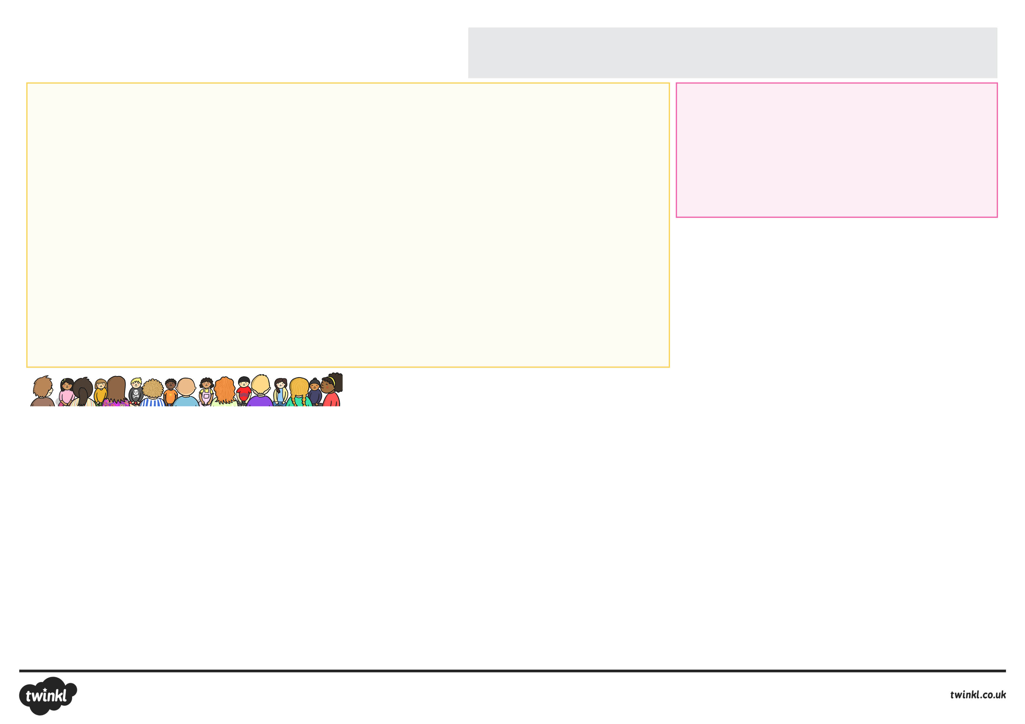
Promoting Independence
Your child will really benefit from being as independent as possible when they start school. Of course teaching staff will always be on hand to help, but children feel a real sense of achievement when they can accomplish things by themselves! Examples include being able to dress and undress independently, as this will really help with PE sessions. Learning to tie shoelaces can be tricky, so provide opportunities to practise this skill and also explore different types of fastenings, for example Velcro.
Children in reception (FS2) will also have access to an outdoor space throughout the day, so being able to put their coat on and zip it up independently will really help them-as will being able to put on a pair of shoes or taking off their jumper when they get hot. It also means that they can get straight to their playing and learning without having to stop and ask an adult for help!
Another important part of being independent at school is being able to use the toilet independently, including washing and drying their hands. It will also be helpful if they are able to blow their nose on a tissue and put it in the bin.
Having lunch independently may also be new to your child. If they will be having hot dinners, practise using a knife, fork and spoon. If they are taking a packed lunch, practise opening the packets and containers of food they will be taking. Encourage them to help choose and make their lunches. Maybe they could use their new school lunchbox and water bottle when you go for a picnic in the park? This would enable them to practise opening their food and learn about their likes/dislikes and suitable items for school lunches.
Your child will also really benefit from having experienced being away from you for short periods of time, such as going to a friend’s house to play. This will really develop their confidence and independence and stand them in good stead when it comes to saying goodbye on that first morning at school.
Social Skills
Being able to interact appropriately with other children and share resources is a key skill that will help your child when they start school. Play dates with other children will help to promote these skills and you could arrange these with future classmates if possible. During the play date, you can model useful social phrases such as ‘my turn please’ or ‘let’s share’ and join in with pretend play to start the game off and then fade out as children get into character.
Preparing Your Child for School
A Guide for Parents and Guardians…

The period before a child starts school for the first time can be an anxious time for parents.
We have put together the following information as a simple guide to how you can best prepare
your child for this exciting time in their lives!
Communication and Language
Many parents worry if their child will be able to tell the teacher if they need something or if they will make friends. Good communication skills underpin these abilities.
Your child may be starting school with identified communication difficulties, or you may have concerns that have not yet been addressed. An easy way to check out concerns is by using the ICAN ‘Progress Checker’. This is an online tool which allows parents to look at what is expected in terms of talking, listening and understanding language for their child’s age range. It’s a simple way to alleviate any unnecessary anxieties or to seek advice if needed.
We know that parents can have a huge impact on their child’s talking and listening development and the summer is a perfect time for trying out simple language boosting activities:
Listening and Attention Skills
Your child will be given many spoken instructions throughout the school day and will need to be able to shift their attention from what they are doing to listening to what the teacher is saying.
A lovely activity to promote this is to go on a ‘listening walk’ where your child listens for all the sounds around them in the park or town centre. You could also jot down all the sounds your child notices and talk about these back at home to retell the journey based on the sounds they heard.
Understanding Spoken Instructions
Classroom instructions often contain several parts for children to remember. A simple game of ‘Simon Says’ during long car journeys this summer could really help. Give your child an instruction to do, like ‘Simon says put your finger on your nose’ and see if they can follow your instruction. The game becomes more difficult as they are only supposed to follow your instructions if you start the sentence with ‘Simon says…’ Can your child listen carefully and only follow the instructions when directed? The game can be made more challenging by building up to instructions with two or three steps, for example ‘Simon says touch your nose, then clap your hands and then put on your hands on your head!’
Vocabulary Development
At school, children will be expected to start extending their vocabulary, so it is a good idea to encourage your child to learn and use new words. You could play sorting games when packing a suitcase, as this is a great way to help word categorisation,
which is important for vocabulary learning. Items can be sorted into different piles, such as clothing, toys and things for washing ourselves.
Outdoor ‘treasure hunts’ work well too. Collecting objects found on walks in the park or on the beach, help introduce new types of vocabulary such as describing words. Treasure can also then be used to create feely bags, where objects have to be described by the way they feel before revealing what the object is.
Narrative Skills
Reception (FS2) age children will be encouraged to use language to organise and sequence ideas and events. Summer days are perfect for creating a photo journal of activities. Your child can then organise pictures into the correct sequence and retell the story in their own way.
You can model important concept words like ‘first’, ‘last’, ‘next’, ‘before’ and ‘after’, and the correct use of past, present and future tenses of verbs, which typically will not yet be fully developed.
Vocabulary Development
Teachers do not expect children to know their alphabet or be able to write sentences when they start school. A good foundation in sound awareness skills, such as rhyming and identifying what sound a word begins with would be helpful. Sharing songs and books is a really good way to support this. You could also say the sounds that letters make, along with their names as you come across them day-to-day.
Encourage your child to develop an interest in books and other forms of text, for example comics, postcards, labels and posters. You could visit your local library and encourage your child to choose books they would like to listen to and look at. Read with your child and discuss what you have read, for example, ask what they liked about it. Consider reading books about ‘starting school’ with your child. Use these to discuss all the fun activities they will be doing
at school.

Mathematical Development
Counting Verbally and One to One
Being able to count verbally to at least 20 will be of great benefit to a child starting school. Practise counting up to 20, and backwards too. One-to-one counting can also be done incidentally throughout the day, for example counting steps as your child climbs the stairs. You can count anything, for instance how many lamp posts are on the street, how many houses have a red door, how many pieces of fruit are in the bowl (and how many did we have
yesterday), how many pencils fit in the pencil case, etc. You can also do this when giving things out, for example: “an ice cream for you, an ice cream for Susie and one for me – 1,2,3 ice creams!” Encourage reliable one to one counting by showing your child how to point to each item as they count, or to move the items as they count so they do not count each item more than once. This will help your child understand what numbers mean. Ask them to find the same amount of different items. For example, find
3 spoons, 3 hats or 3 socks. You can also sing counting songs, many of which are available if you search for ‘number rhymes’ on the Twinkl website.
Shape, Size and Quantity
You could go on a shape hunt to see how many circles, squares, rectangles and triangles your child can find, for example square windows, circular plates, and rectangular posters. You could look for patterns too. Talk about the shape and size of objects, e.g. big car, little car, round ball, square table, rectangular book and ask your child questions such as ‘Can you pass me the biggest box?’, or
‘Which one is the smallest shoe?’. Play with blocks and encourage your child to think about size, colour and shape. Also play with containers and ask, ‘How many socks can you fit in the box?’, ‘Which container holds the most, or the least, sand/water?’, etc.
Number Recognition
A number hunt is a fun way to look for numerals on doors, on clocks, buses, cars, signs, at home, at the shops or on TV. You could also play ‘I spy’ but with numbers.
Other Things to Bear in Mind:

- Use every day experiences as learning opportunities, for example take your child with you to the shops. They can learn about:
  - reading and writing as you write and follow a shopping list;
  - practise their listening and memory skills and extend their vocabulary by helping you to collect named items;
  - learn about numbers, counting and money when helping you to pay for items;
  - learn about their local environment on the way to and from the shops, etc.
- Encourage your child to help you with simple jobs around the home, for example gardening, tidying up, baking and cooking. This will help them to develop coordination and listening skills as well as independence and self-confidence.
- Explore different ways of being creative, for example:
  - colouring and drawing with pens, pencils and crayons, painting;
  - cutting and sticking materials together;
  - building models with ‘junk’ materials like cardboard boxes or construction toys like Lego;
  - exploring sounds made by instruments or ‘noise makers’ (for example rice in an empty yoghurt pot) and listening to and moving to music.
- You could invite a friend to play at your house for a short while. This will hopefully make the settling in process a little easier as they will already have a familiar face in the school or class. This will also help develop their communication and social skills.
- Remember that everything your child wears or takes into school needs to be named – this includes coats, scarves, gloves, hats, shoes and toys. Consider buying iron-on name labels as a quick way to name everything at once or use a permanent laundry marker. When naming shoes, also help your child to know which shoe goes on to which foot by drawing half a picture (like a smiley face) into the left shoe and the other half of the picture into the right shoe – when the shoes are placed correctly the picture will look complete!
- Ask your child to help name their uniform/clothes and school equipment like drinks bottle and lunch box. This will aid name recognition and help them to identify which things are theirs!
- Most schools offer fruit as a snack during the day. Encourage your child to try a range of different fruit to explore their likes and dislikes and also practise peeling bananas and oranges.
- Encourage your child to be active. Help them to explore climbing equipment in a local park, play running games, practise riding a bike or a scooter and play simple games with a ball or frisbee.
- It may help your child to choose a small toy that they would like to take with them to school (ensure that it is named). This can act as a comfort for your child and also encourage them to talk to others. Please check school rules before agreeing that this can happen.
- Lots of schools offer a home visit which allows staff to visit you and your child in your own home setting. This enables your child to meet their new teacher in a setting where they feel more secure and relaxed. Don’t worry about these meetings – it is just a chance for staff to begin to get to know your child, collect any important information about your child and pass on any information about the school. It is also an opportunity for you to ask any questions you may have and pass on any information about your child. You might find it helpful to prepare some questions in advance.

Reading & Writing continued
You can also develop an interest in reading by reading notices and labels when away from home and postcards or greetings cards from family members or friends.
‘Name Treasure Hunts’ can be a fun way of getting your child to recognise their name. Write your child’s name on pieces of paper and hide them around the house. Encourage your child to find them all. Other names (or words) can then be introduced to encourage your child to look carefully at each letter of their name.
A good foundation to being able to write is to develop your child’s fine motor skills. This is because good fine motor skills enable a child to hold a pencil firmly as they are writing. There are many resources that could support the development of this skill on the Twinkl website, just search for ‘fine motor skills’. Threading is also a great way to develop fine motor skills, whether it is with beads or buttons, or making necklaces out of dried pasta. Weaving wool around a cardboard template or strips of card through each other are also other simple activities that you could do at home. As is playing with handheld construction toys, small toys and cutting and sticking activities.
If your child is ready and interested in writing, encourage them to write simple words or sentences. Initially, begin by focusing on your child’s name as this will also help with reading and name recognition. Encourage them to write their name into greetings cards, on to artwork they have done or on to letters and postcards for friends and family.

